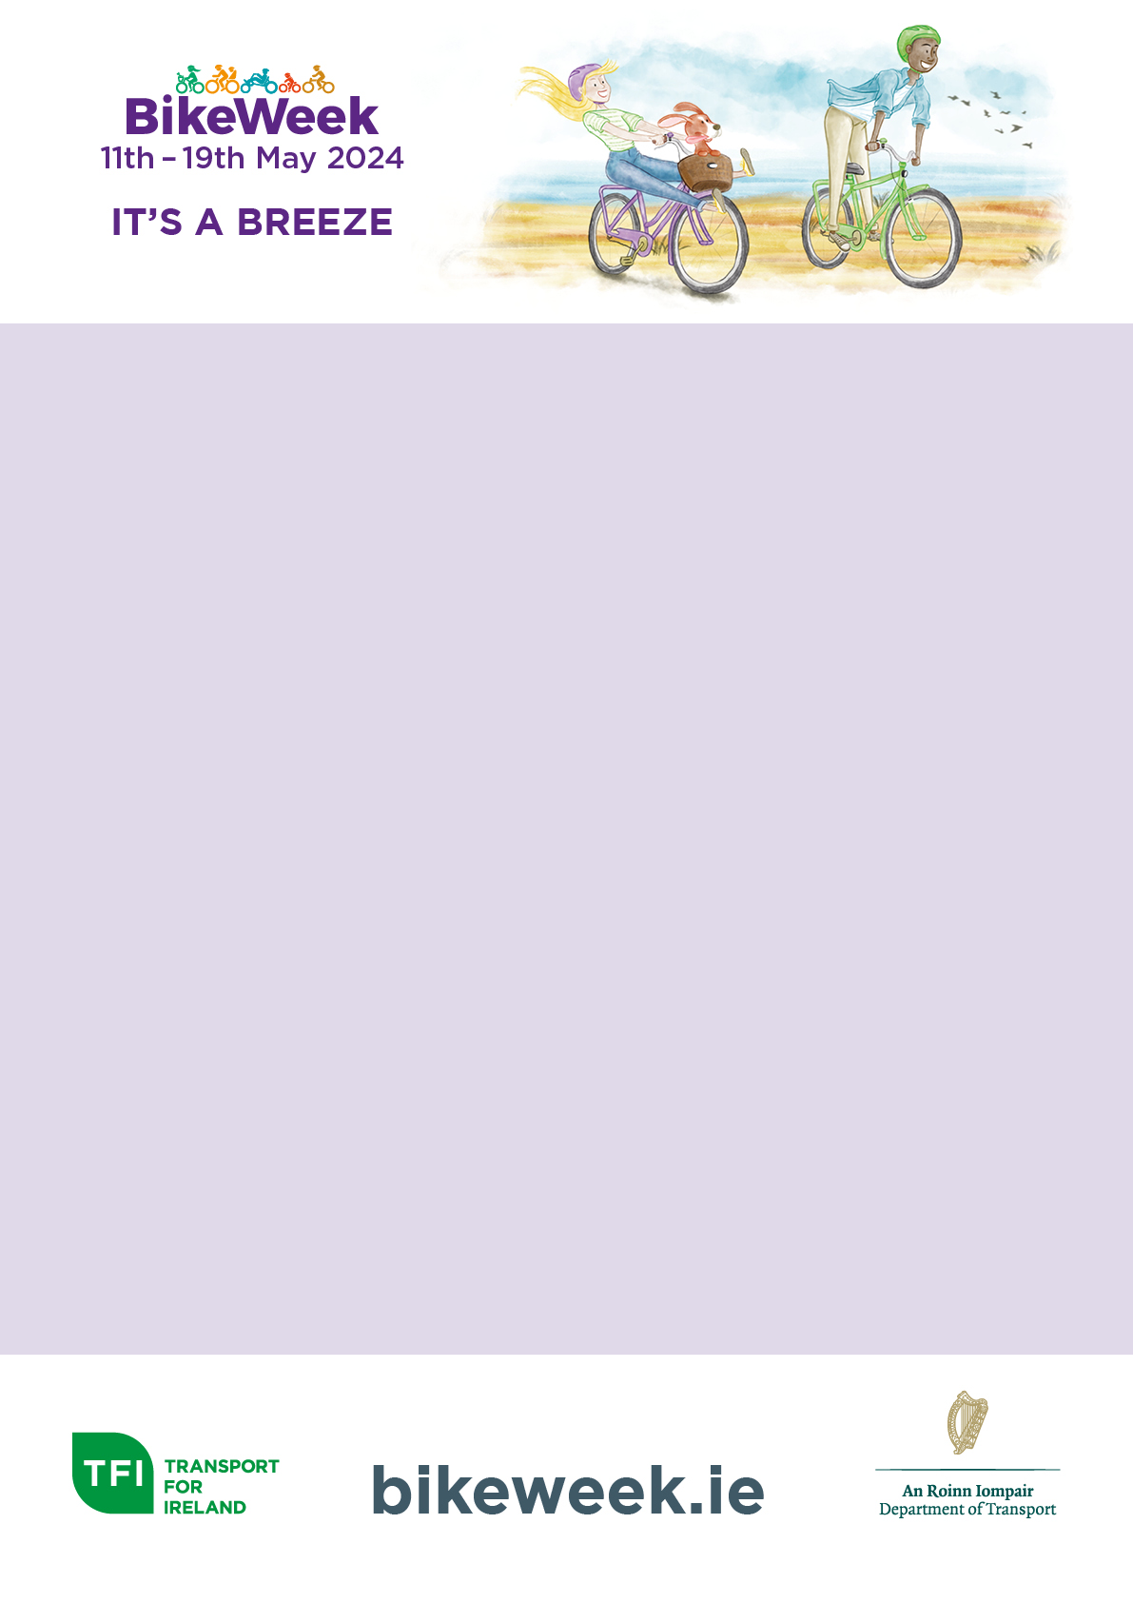

Description:

Leisure Cycle

Date:

Saturday 13th May

Time:

10am

Start/Finish Point:

St. Anne’s Park, Clontarf, Dublin 3

Age Limit:

All ages and abilities